# Sprint 3

MIT App Inventor and Dashboard-

Application for project using MIT App, Design the Model and Test the App

|  |  |
| --- | --- |
| Date | 8 October 2022 |
| Team ID | PNT2022TMID23506 |
| Project Name | Project – Smart Farmer-IoT Enabled smart Farming Application |
| Maximum Marks | 4 Marks |

# Configuration of Node-Red to send commands to IBM cloud

ibmiot out node I used to send data from Node-Red to IBM Watson device. So, after adding it to the flow we need to configure it with credentials of our Watson device.

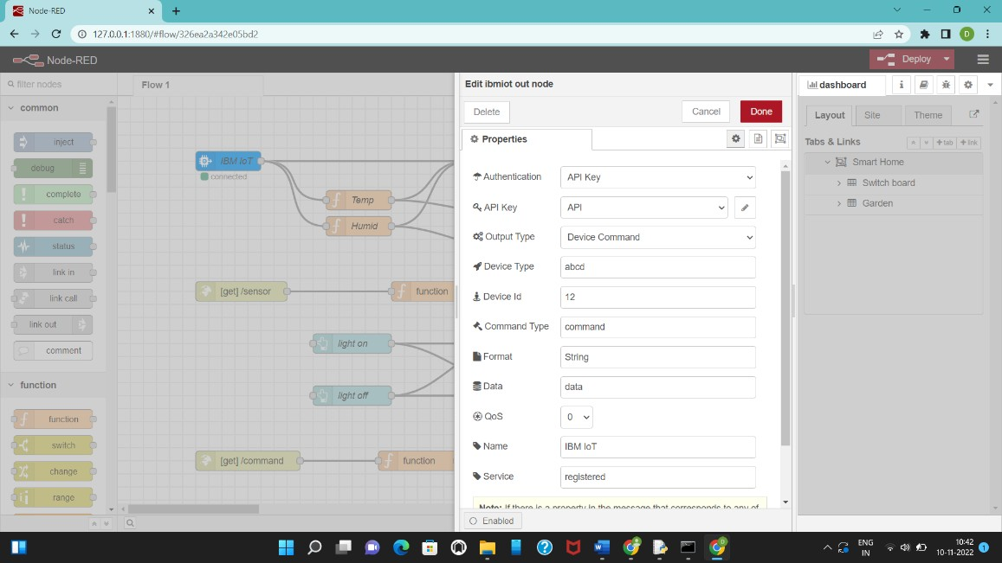

Here we add two buttons in UI 1.Light On

2.Light Off

The Java script code for the analyses is: if(msg.payload===1) msg.payload={"command”: “ON"};

else if(msg.payload===0) msg.payload={"command”: “OFF"};

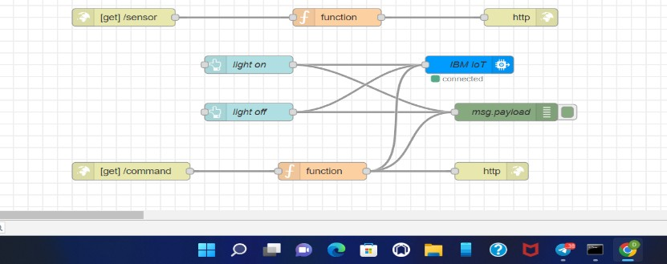 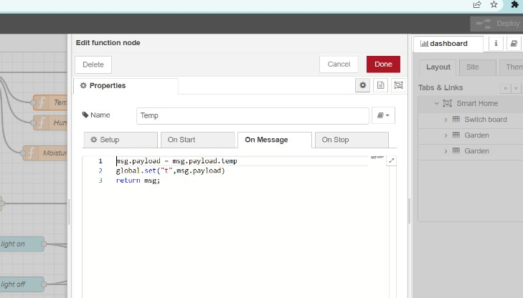

## Adjusting User Interface

In order to display the parsed JSON data a Node-Red dashboard is created

Here we are using Gauges, text and button nodes to display in the UI and helps to monitor the parameters and control the farm equipment.

Below images are the Gauge, text and button node configurations.

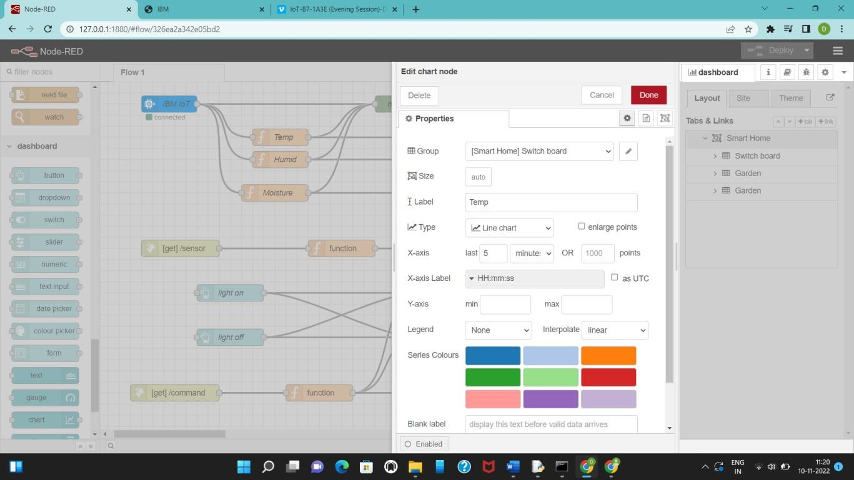

## Complete Program Flow

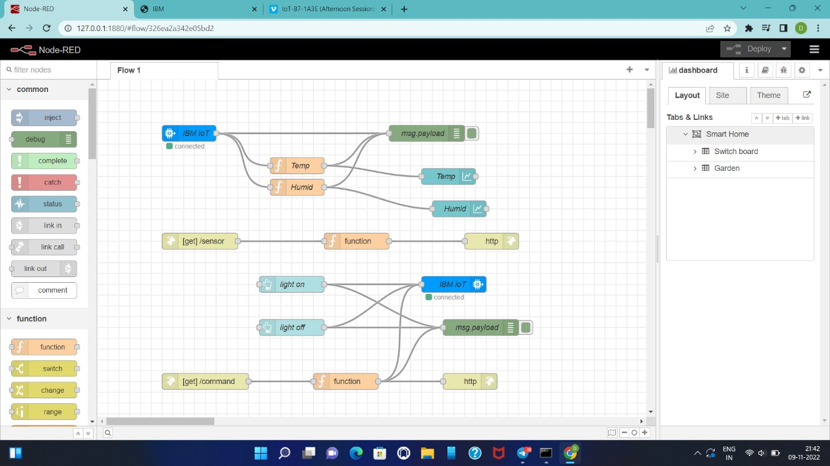

MOBILE APP WEB :

# BLOCK DIAGRAM

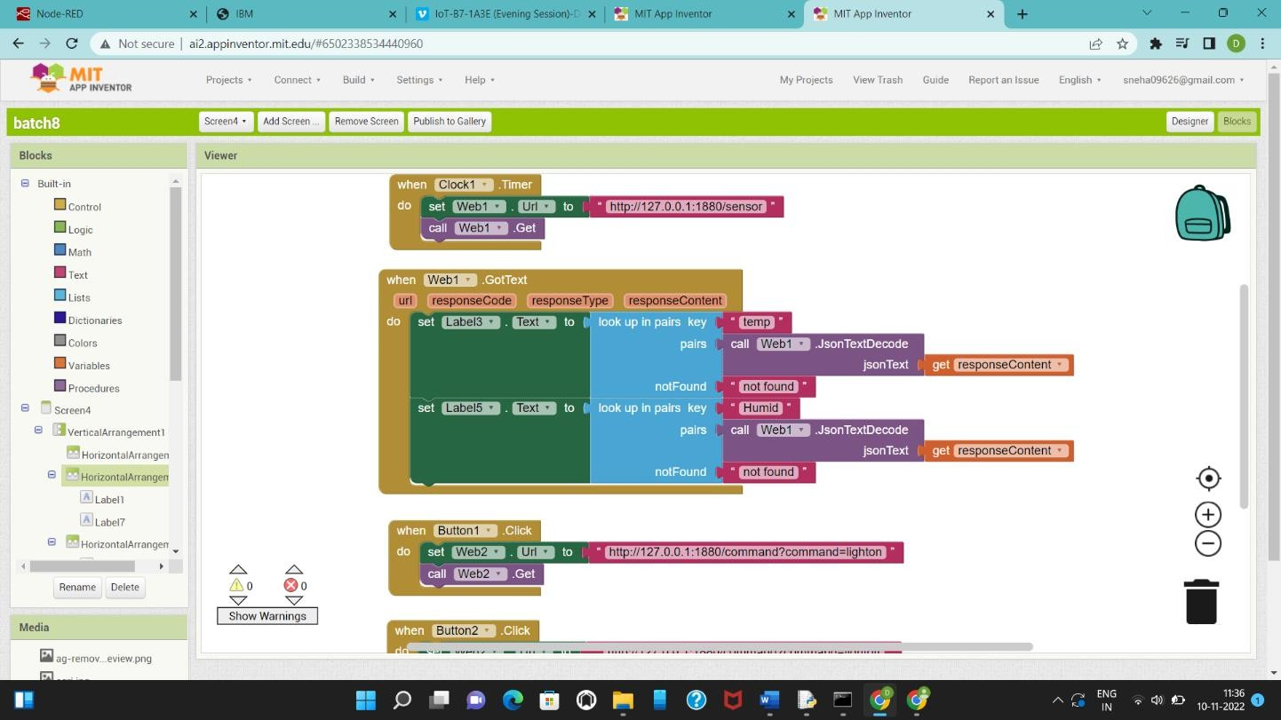

**SCREEN – 1 SCREEN – 2**

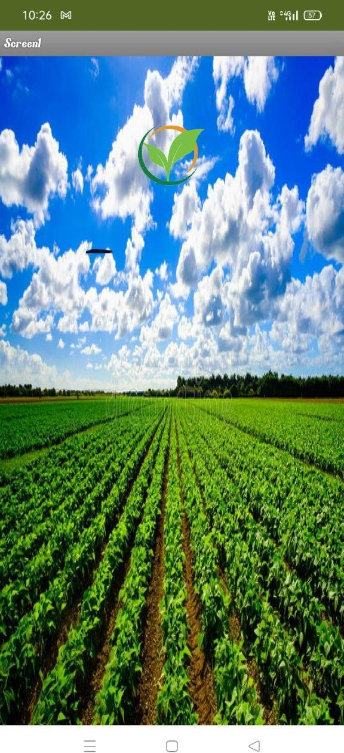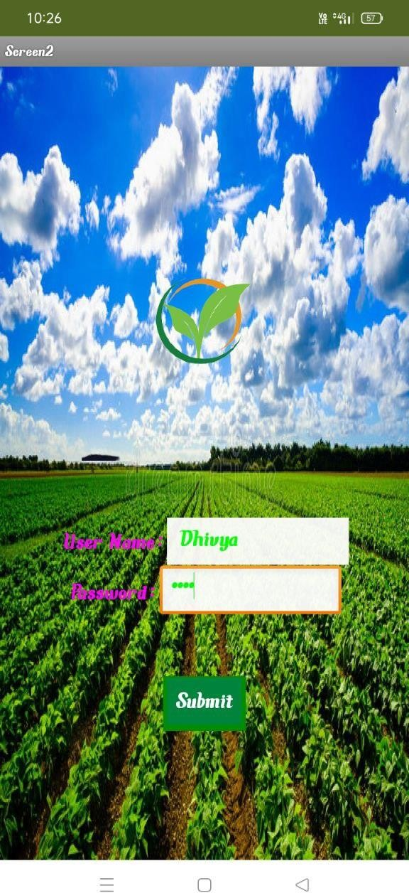

# SCREEN - 3

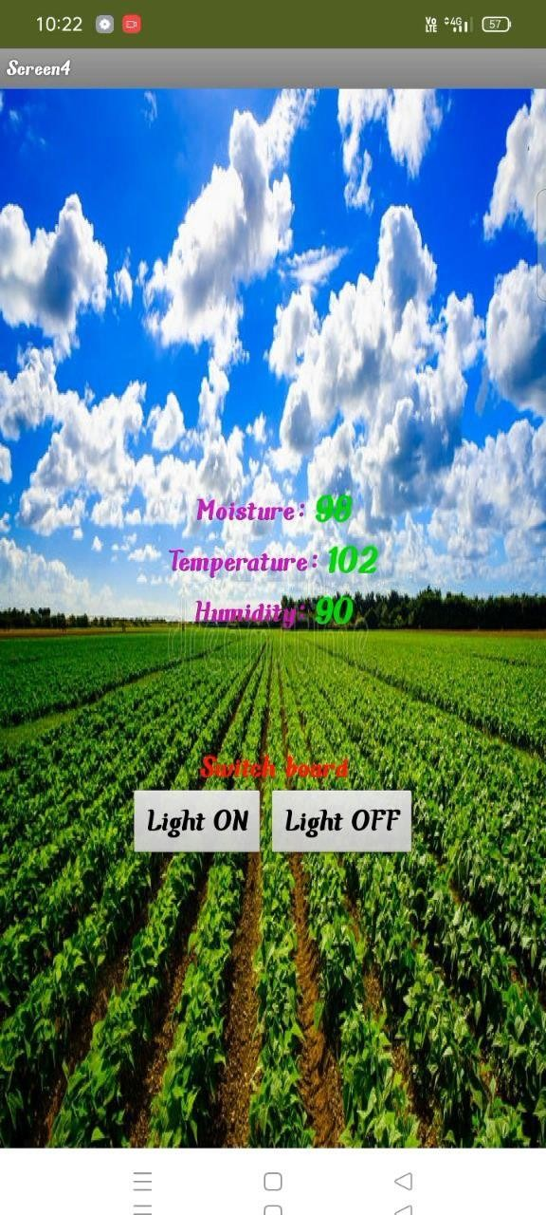

## Web APP UI Home Tab

